**Use case: Place Order**

**Place Order Class diagram**

**Note:** methods set/get for each entities are many and simple, so they will not be included in diagram just illustrated in class ‘DeliveryInfo’ bellow as an example

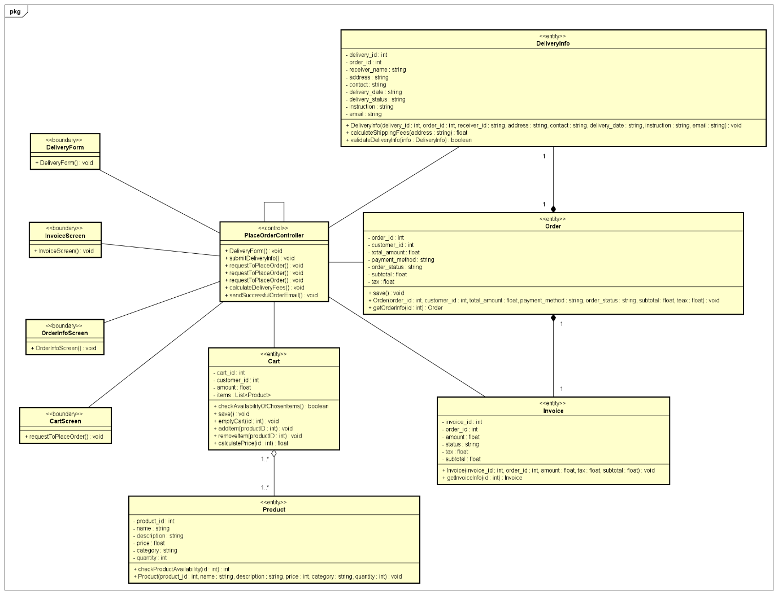

**Design class**

1. **DeliveryInfo**

**Attributes table:**

|  |  |  |  |  |
| --- | --- | --- | --- | --- |
| # | Name | Data type | Default value | Description |
| 1 | delivery_id | int | null | unique identifier for each delivery |
| 2 | order_id | int | null | unique identifier for order associated with delivery |
| 3 | receiver_name | string | null | name of the receiver |
| 4 | address | string | null | delivery address |
| 5 | contact | string | null | phone number of receiver |
| 6 | delivery_date | string | null | expected delivery date |
| 7 | delivery_status | string | ‘Processing’ | status of delivery |
| 8 | instruction | string | null | instruction given by customer |

**Operations table:**

|  |  |  |  |
| --- | --- | --- | --- |
| # | Name | Return type | Description |
| 1 | setDeliveryAddress(address: string) | void | update delivery address |
| 2 | getDeliveryAddress() | string | return delivery address |
| 3 | setReceivername(name: string) | void | update name of receiver |
| 4 | getReceiverName() | string | return receiver’s name |
| 5 | setContact(contact: string) | void | update receiver phone number |
| 6 | getContact() | string | return receiver’s phone number |
| 7inf | setDeliveryDate(date: string) | void | update expected delivery date |
| 8 | getDeliveryDate() | string | return expected delivery date |
| 9 | setDeliveryStatus(status: string) | void | update current delivery status |
| 10 | getDeliveryStatus() | string | return current delivery status |
| 12 | calculateShippingFee(address: string) | float | calculate shipping fees based on receiver address |
| 13 | validateDeliveryInfo(info: DeliveryInfo) | boolean | check if information input to delivery form is valid or not |
| 14 | DeliveryInfo(delivery_id : int, order_id : int, receiver_id : string, address : string, contact : string, delivery_date : string, instruction : string, email : string) | void | construction method to create a new DeliveryInfo |

**Parameters:**

* delivery_id: int, this parameter is used to view the information of delivery
* order_id: int, this parameter is used to view the information of delivery
* receiver_name: string, this parameter is used to view the information of delivery
* address: string, this parameter is used to view the information and calculate shipping fees of delivery
* contact: string, this parameter is used to view the information of delivery
* delivery_date: string, this parameter is used to view the information of delivery
* delivery_status: string, this parameter is used to view the information of delivery
* instruction: string, this parameter is used to view the information of delivery

**Exceptions:**

* DatabaseConnectionException: exception thrown when database is unreachable while updating or fetching delivery information

**Methods:**

* set/get… methods: update delivery information from delivery form/ return delivery information
* calculateShippingFees(address: string): float
  + when delivery address is updated, shipping fees is automatically calculated and updated
* validateDeliveryInfo(info: DeliveryInfo): Boolean
  + when any fields updated, check their validity
  + if all fields are valid, return True
  + if any field is invalid, return False
* DeliveryInfo(delivery_id : int, order_id : int, receiver_id : string, address : string, contact : string, delivery_date : string, instruction : string, email : string): void
  + create a new DeliveryInfo
  + when first created, the delivery_status will be ‘Processing’ by default

**States:**

* Valid: all delivery fields are valid
* Invalid: any field is invalid

1. **Order**

**Attributes table:**

|  |  |  |  |  |
| --- | --- | --- | --- | --- |
| # | Name | Data type | Default value | Description |
| 1 | order_id | int | null | unique identifier for each order |
| 2 | customer_id | int | null | unique identifier for each customer associated with order |
| 3 | total_amount | float | null | total money of products and tax |
| 4 | subtotal | float | null | total money of products |
| 5 | tax | float | null |  |
| 6 | order_status | string | ‘Processing’ | status of order |
| 7 | payment_method | string | null | method customer choose to pay |

**Operations table:**

|  |  |  |  |
| --- | --- | --- | --- |
| # | Name | Return type | Description |
| 1 | save() | void | store order information into database |
| 2 | Order(order_id : int, customer_id : int, total_amount : float, payment_method : string, order_status : string, subtotal : float, teax : float) | void | construction method to create a new Order |
| 3 | getOrderInfo(id: int) | Order | retrieve all information of an order |

**Parameters:**

* order_id: int, this parameter is used to view the information of order
* customer_id: int, this parameter is used to view the information of order
* total_amount: float, this parameter is used to view the information of order
* subtotal: float, this parameter is used to view the information of order
* tax: float, this parameter is used to view the information of order
* order_status: string, this parameter is used to view the information of order
* payment_method: string, this parameter is used to view the information of order

**Exception:**

* InvalidOrderException: when order details are incomplete or invalid
* DatabaseConnectionException: database is unreachable while processing order
* OrderNotFoundException: when request for order based on order ID does not exist

**Methods:**

* save(): void
  + when order is created, order is stored to database
* Order(order_id : int, customer_id : int, total_amount : float, payment_method : string, subtotal : float, teax : float): void
  + contruction method to create a new order
  + when created, order_status is ‘Processing’ by default
* getOrderInfo(): Order
  + retrieve all order information

**States:**

* Processing: order is placed and waiting for acception or rejection
* Accepted: order is accepted by product manager
* Rejected: order is rejected by product manager
* Delivered: order is delivered to destination
* Cancelled: order is cancelled by customer

1. **Invoice**

**Attributes table:**

|  |  |  |  |  |
| --- | --- | --- | --- | --- |
| # | Name | Data type | Default value | Description |
| 1 | invoice_id | int | null | unique identifier for each invoice |
| 2 | order_id | int | null | unique identifier for order associated with invoice |
| 3 | amount | float | null | total amount to pay |
| 4 | status | string | ‘Waiting payment’ | status of invoice |
| 5 | subtotal | float | null | total amount of products |
| 6 | tax | float | null |  |

**Operations table:**

|  |  |  |  |
| --- | --- | --- | --- |
| # | Name | Return type | Description |
| 1 | Invoice(invoice_id : int, order_id : int, amount : float, tax : float, subtotal : float) | void | construction method to create a new Invoice |
| 2 | getInvoiceInfo(id: int) | Invoice | input invoice_id and retrieve invoice’s information |

**Parameters:**

* invoice_id: int, this parameter is used to view the information of invoice
* order_id: int, this parameter is used to view the information of invoice
* amount: float, this parameter is used to view the information of invoice
* status: string, this parameter is used to view the information of invoice
* tax: float, this parameter is used to view the information of invoice
* subtotal: float, this parameter is used to view the information of invoice

**Exception:**

* InvoiceNotFoundException: when request for invoice based on invoice ID does not exist
* PaymentFailedException: when payment transaction cannot be completed (insufficient fund,…)
* InvoiceAlreadyPaidException: when payment for this invoice has already been made
* DatabaseConnectionException: when database is unreachable while fetching or updating invoice

**Methods:**

* Invoice(invoice_id : int, order_id : int, amount : float, tax : float, subtotal : float): void
  + this is a construction method used to create new invoice when order is accepted
* getInvoiceInfo(id: int): Invoice
  + retrieve all invoice information

**States:**

* Waiting payment: when invoice has been created, and customer has not paid yet
* Paid: customer has paid

1. **Cart**

**Attributes table:**

|  |  |  |  |  |
| --- | --- | --- | --- | --- |
| # | Name | Data type | Default value | Description |
| 1 | cart_id | int | null | unique identifier for each cart, but this ID is temporary |
| 2 | customer_id | int | null | unique identifier for customer associated with cart |
| 3 | amount | float | null | total amount of products in cart |
| 4 | items | List<Product> | null | list of product int cart; if there are more than 1 product of the same type, it will appear many time in the list |

**Operations table:**

|  |  |  |  |
| --- | --- | --- | --- |
| # | Name | Return type | Description |
| 1 | checkAvailabilityOfChosenItems(List<Product>) | boolean | loop through list of items of a cart and check availability of each product |
| 2 | save() | void | temporarily save cart for processing, not store to database |
| 3 | emptyCart(id: int) | void | empty cart with given id |
| 4 | addItem(productID: int) | void | add item to cart |
| 5 | removeItem(productid: int) | void | remove product from cart |
| 6 | calculatePrice(id: int) | float | calculate total price of products in a cart |

**Parameters:**

* cart_id: int, this this parameter is used to view the information of cart
* customer_id: int, this this parameter is used to view the information of cart
* amount: float, this this parameter is used to view the information of cart
* items: list<Product>, this this parameter is used to view the information of cart

**Exception:**

* AddingItemFailedException: when cannot add item into cart for some reasons (not enough quantity, wrong product id,…)
* RemoveItemFailedException: when cannot remove item from cart because item has been removed

**Methods:**

* checkAvailabilityOfChosenItems(List<Product>): Boolean
  + check availability of chosen item before adding to cart
* save(): void
  + save cart temporarily on system for later processing
* emptyCart(id: int): void
  + used to empty cart after place order complete
* addItem(productID: int): void
  + used to add chosen items into cart
* removeItem(productid: int): void
  + remove chosen items from cart
* calculatePrice(id: int): float
  + calculate total price of products in cart

**States:**

* Empty: cart is existing but no items inside
* Active: cart contains items inside, but no further process
* Processing: user choose to place order for this cart and system is processing further steps
* If user left before place order, cart will be deleted, so this is no state

1. **Product**

**Attributes table:**

|  |  |  |  |  |
| --- | --- | --- | --- | --- |
| # | Name | Data type | Default value | Description |
| 1 | product_id | int | null | unique identifier of each product |
| 2 | name | string | null | name of product |
| 3 | description | string | null | description of product |
| 4 | price | float | null | price of product |
| 5 | category | string | null | category of product |
| 6 | quantity | int | null | quantity of product |

**Operations table:**

|  |  |  |  |
| --- | --- | --- | --- |
| # | Name | Return type | Description |
| 1 | Product(product_id : int, name : string, description : string, price : int, category : string, quantity : int) | void | construction method to create a new product |
| 2 | checkProductAvailability(id: int) | int | check product availability |

**Parameters:**

* product_id: int, this this parameter is used to view the information of product
* name: string, this this parameter is used to view the information of product
* description: string, this this parameter is used to view the information of product
* price: float, this this parameter is used to view the information of product
* category: string, this this parameter is used to view the information of product
* quantity: int, this this parameter is used to view the information of product

**Exception:**

* DuplicateProductException: when intending to change product quantity or price, product manager tries to create a product has already exist (check based on name) instead of update product quantity or prices
* DatabaseConnectionException: database is unreachable while retrieving product data

**Methods:**

* Product(product_id : int, name : string, description : string, price : int, category : string, quantity : int): void
  + a construction method used to create a new product
  + this also check if the product has already existed in database
* checkProductAvailability(id: int): int
  + retrieve the number of available products
  + return 0 if there is no products left

**States:**

* Available: product’s quantity is available in database
* Unavailable: product’s quantity is unavailable in database